AirLink – Personnel Management Application Design Document

Contents
1 Introduction 3
1.1 Intent 3
2 AIRLINK Use Cases 4
2.1 Intent 4
2.2 Use Cases 4
3 Business Rules 5
4 Class diagram 6
4.1 Domain Layer Class Diagram 6
4.2 Service Layer Class Diagram 7
4.3 Business Layer Class Diagram 7
4.4 Presentation Layer Class Diagram 8
4.5 Sequence Diagrams 9
5 Project Screenshots 12

Introduction

Intent
This document reimagines the Air Force’s approach to managing personnel at the unit level. Software has relentlessly transformed the modern world, to include the military and the way it wages war. Despite this proliferation of tools and data, at the squadron level the tools to manage personnel remain incoherent, redundant, and stovepiped, forcing commanders’ staffs to rely on individually crafted spreadsheets. There is a dire need for quality personnel management software to eliminate the load and generate quality data.
AirLink will bring order to the chaos, providing accurate personnel profiles, precision accountability, responsive job assignments, and long term scheduling. The military has several different personnel software systems, but none are geared toward a squadron’s staff. This results in accountability being maintained on a mixture of Excel or Access based products. These tend to be highly redundant, quickly outdated, and offer no real visibility into people’s daily activities. Collecting this disparate information into a database program would ease accountability exercises and enable insightful personnel decisions. Additionally, commanders place a great emphasis on developing people and rotating personnel amongst jobs, but the placement can be reactionary, not proactive. It’s not uncommon for a job to become vacant before a replacement comes along, leaving no handover and a learning nightmare for new hires. AirLink would allow real time job availability awareness by assigning personnel to offices and highlighting when a conflict or vacancy is approaching. Finally, consolidating personnel data would allow for accurate long term planning by deconflicting deployments, temporary assignments, and long term commitments. This information would be entered and immediately available to the commander’s staff, squadron schedulers, and individual squadron members.
A military organization can be very complex, but the personnel tools don’t have to be. A database driven application would pave the way for proactive personnel management and provide instantaneous visibility into the pulse of a squadron.

AIRLINK Use Cases

Intent
The application will be geared towards the Commander’s staff, where a handful of administrators generate profiles, track manning and assign jobs for the squadron. Future iterations can provide an individual portal and event scheduling.

Use Cases

The following Use Cases are arranged according to user priority:

- Register Employee
- Edit Employee Profile
- Generate Manning Report
- Generate Squadron Job
- Edit Job Information
- Assign Employee(s) to Job
- Generate Job Manning Report
- Authenticate User
- Archive Employee
- Remove Squadron Job
- Generate Squadron Family Report

Business Rules

- Employees require a complete name, address, and contact information for accountability
- Family members require, at minimum, a complete name and an e-mail address
- Employees may belong to only one flight
- Employees may be assigned to any number of jobs
- An employee’s family may include another employee
- If an employee is married to another employee they must be similar rank. An officer – enlisted relationship will raise a warning

Class diagram

Domain Layer Class Diagram
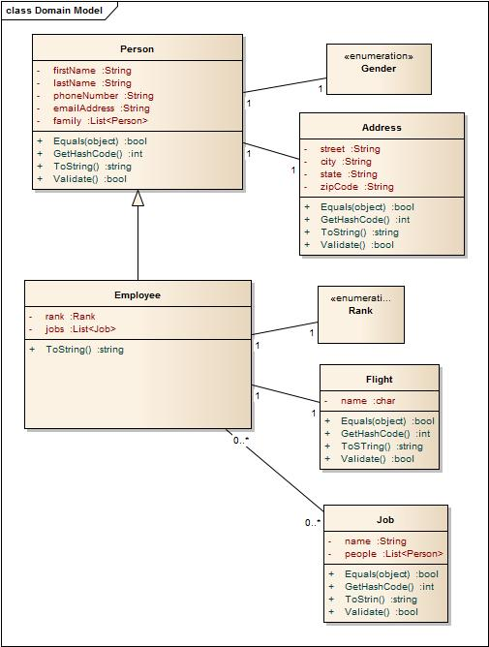
Figure 4-1 Domain Layer Class Diagram

Service Layer Class Diagram
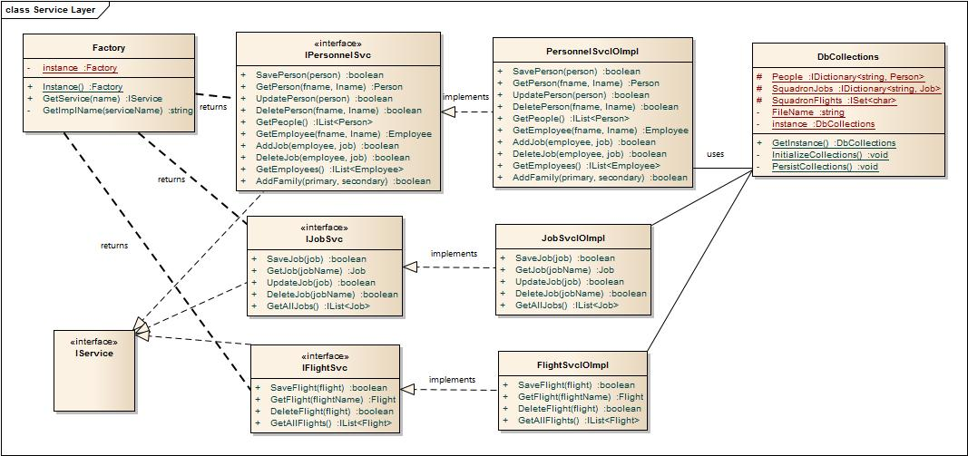
Figure 4-2 Service Layer Class Diagram

Business Layer Class Diagram
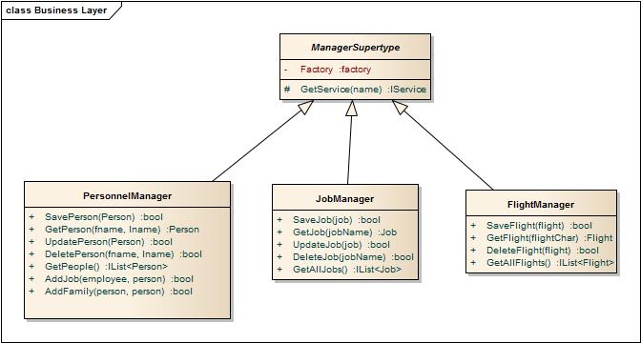
Figure 4-3 Business Layer Class Diagram

Presentation Layer Class Diagram
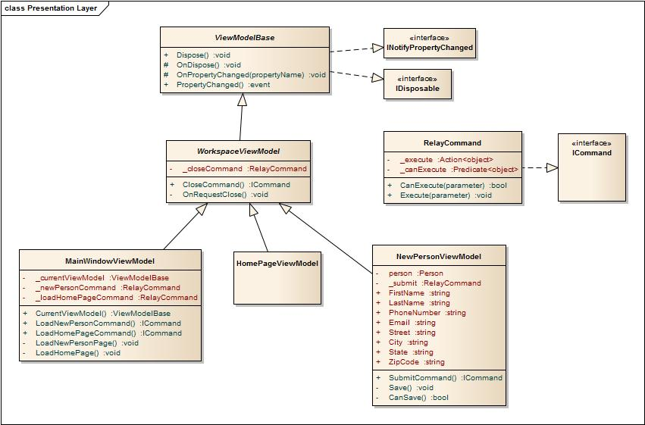
Figure 4-4 Presentation Layer Class Diagram

Sequence Diagrams
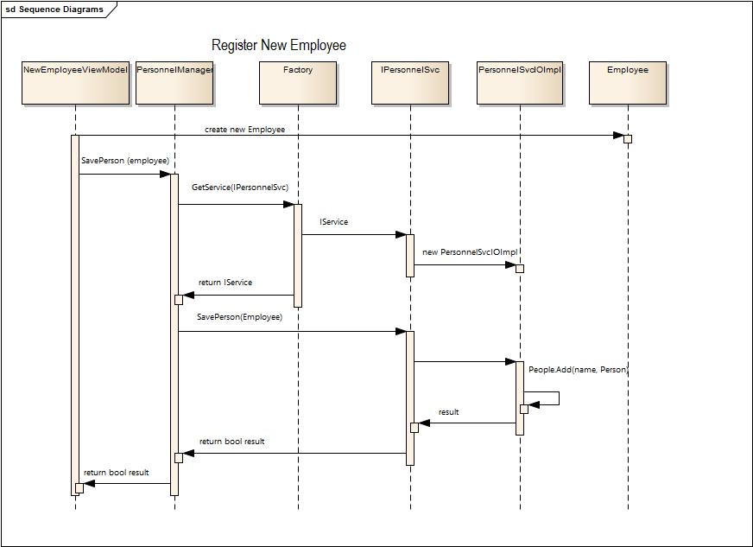
Figure 4-5 Register New Employee Diagram
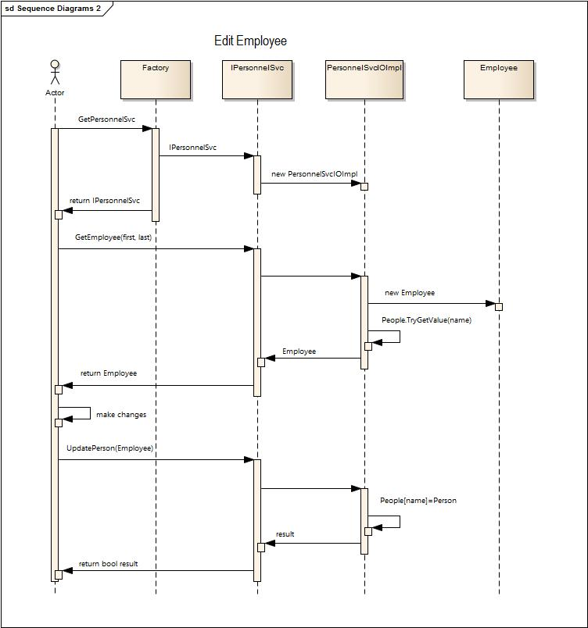
Figure 4-6 Edit Employee Diagram

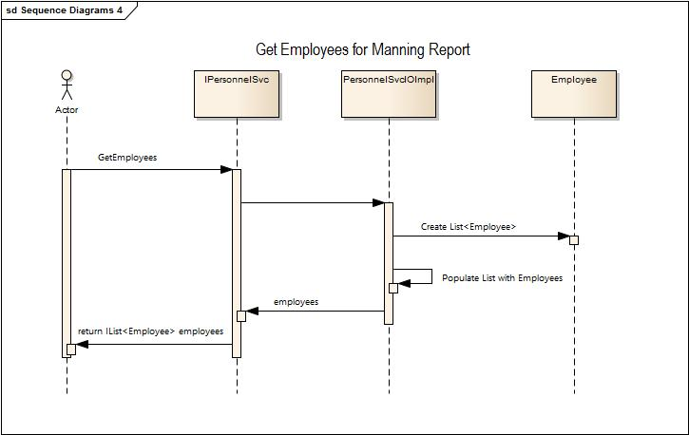
Figure 4-7 Get Employee Roster Diagram
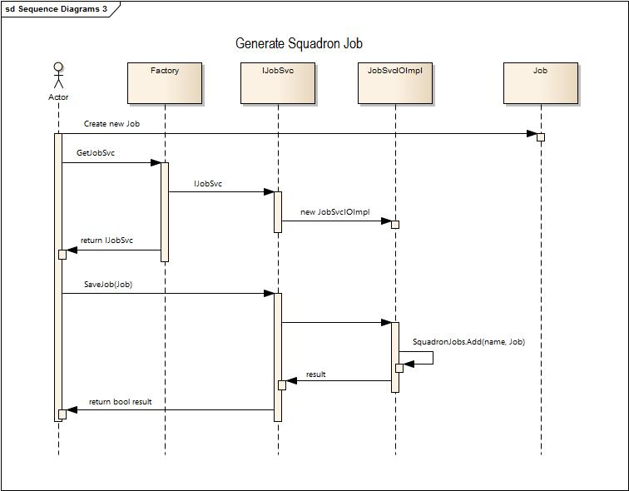
Figure 4-8 Generate Squadron Job Diagram

Project Screenshots
Project UI – Home page, New Employee page, Edit Employee Page
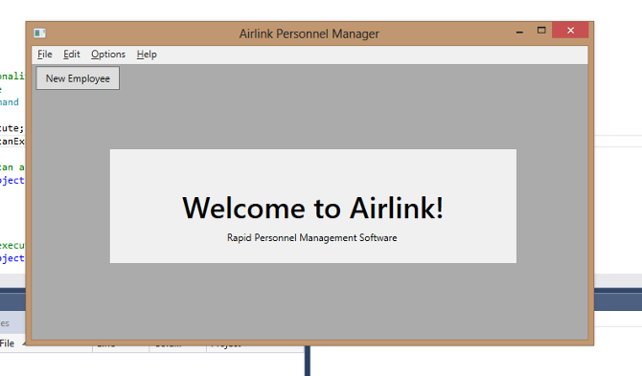

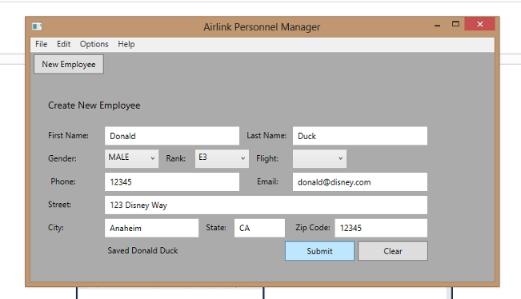
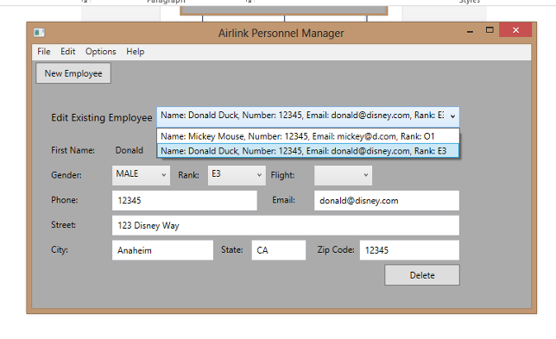

Proposed Final UI
